H.T No
Regulations:
A18

Sreenidhi Institute of Science and Technology
(An Autonomous Institution)
Code No: 7BC02 Date: 12-Sept-2024 (FN)

B.Tech I-Year I- Semester External Examination, September-2024 (Supplementary)
ENGINEERING GRAPHICS AND DESIGN (EEE, ME and ECE)

Time: 3 Hours Max.Marks:70

Note: a) No additional answer sheets will be provided.
b) All sub-parts of a question must be answered at one place only, otherwise it will not be valued.
c) Missing data can be assumed suitably.
Bloom's Cognitive Levels of Learning (BCLL)

Remember | L1 | Apply | L3 | Evaluate | L5
Understand | L2 | Analyze | L4 | Create | L6

Part - A Max.Marks:20

Answer all QUESTIONS.

 |  | BCLL | CO(s) | Marks
1 | Explain the principle of a diagonal scale? | L2 | CO1 | [2M]
2 | Define the trace of a line? What are various types of the traces of a line? | L1 | CO2 | [2M]
3 | Differentiate between Perpendicular planes and Oblique planes. | L4 | CO3 | [2M]
4 | Explain section plane and section with an example. | L2 | CO4 | [2M]
5 | Explain isometric scale with an example. | L2 | CO5 | [2M]
6 | List out the advantages of converting Isometric projection into orthographic projection. | L1 | CO6 | [2M]
7 | List out different types of projections with one example. | L1 | CO1 | [2M]
8 | Compare any two methods of surfaces of development. | L5 | CO3 | [2M]
9 | Describe the need of isometric projections in industrial applications. | L1 | CO5 | [2M]
10 | Explain the procedure to identify missing lines or missing views in orthographic projections. | L2 | CO2 | [2M]

Part – B Max.Marks:50
ANSWER ANY FIVE QUESTIONS. EACH QUESTION CARRIES 10 MARKS.

 |  |  | BCLL | CO(s) | Marks
11. |  | Draw a conical curve if eccentricity is 7/4 and the focus is at a distance of 40mm from directrix | L3 | CO1 | [10M]
12. |  | Draw the projections and shows its inclination with H.P. of a line AB, 65mm long has its end A 20mm above H.P and 25mm in front of VP. The end B is 40mm above H.P and 65mm in front of V.P. | L3 | CO2 | [10M]
13. |  | Draw the projections of a thin circular plate of 40mm diameter having its plane vertical and inclined at 40⁰ to V.P. Its center is 35mm above H.P. and 30mm in front of V.P. | L3 | CO3 | [10M]
14. |  | Draw the development of a cylinder of diameter 45mm and height 70mm is resting on its base on HP. A section plane inclined at 50⁰ to HP, cuts the axis at a distance of 30 mm from top. | L1 | CO4 | [10M]
15. |  | Draw an isometric view of a hexagonal prism having a base with 25 mm side and a 65 mm long axis, which is lying on the H.P. with axis parallel to H.P. | L3 | CO5 | [10M]
16. |  | Draw the front view, Top view and Side view of the figure given below?  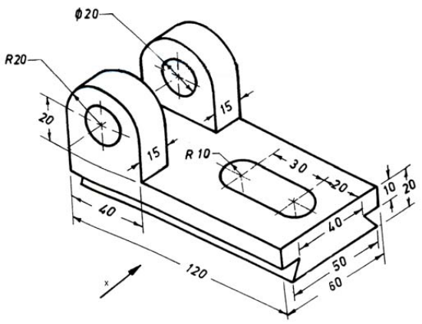 | L3 | CO6 | [10M]
17. | a) | Draw an involute of a circle radius 20mm | L1 | CO1 | [4M]
 | b) | Draw the projections of the St. line and its Traces of 70mm long line PQ is parallel to HP & VP. It is 20mm in front of VP and 15mm above HP. | L1 | CO2 | [3M]
 | c) | Draw the projections of a rectangular plane of sides 40mm and 25 mm is perpendicular to HP and parallel to VP. The nearest side being 10 mm above HP and 20 in front of VP. | L1 | CO3 | [3M]
18. | a) | Draw the projections and the true shape of the section of a vertical cylinder 50 mm is cut by an A. V.P. making 30⁰ to the V.P in such a way that the true shape of the section is a rectangle of 40 mm x 80 mm sides. | L1 | CO4 | [4M]
 | b) | Draw an isometric view of frustum of Cone with a 60 mm base diameter, 40 mm top diameter and 70mm long axis resting on its base on the HP? | L1 | CO5 | [3M]
 | c) | Draw the front view, Top view of the figure given below?  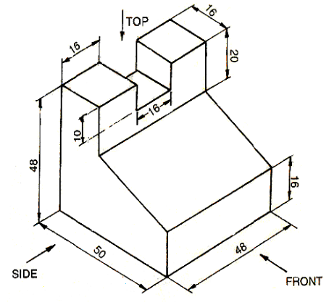 | L1 | CO6 | [3M]

-- 00 -- 00 –

